Deadline: 27.10.2023

Things to do:

1. SGD/ADAM
2. Learning rate (10^-5 , 10^-3)
3. Imbalanced Dataset, Weighted Cross Entropy
4. Architecture NN
5. Early Stopping
6. Data Augmentation

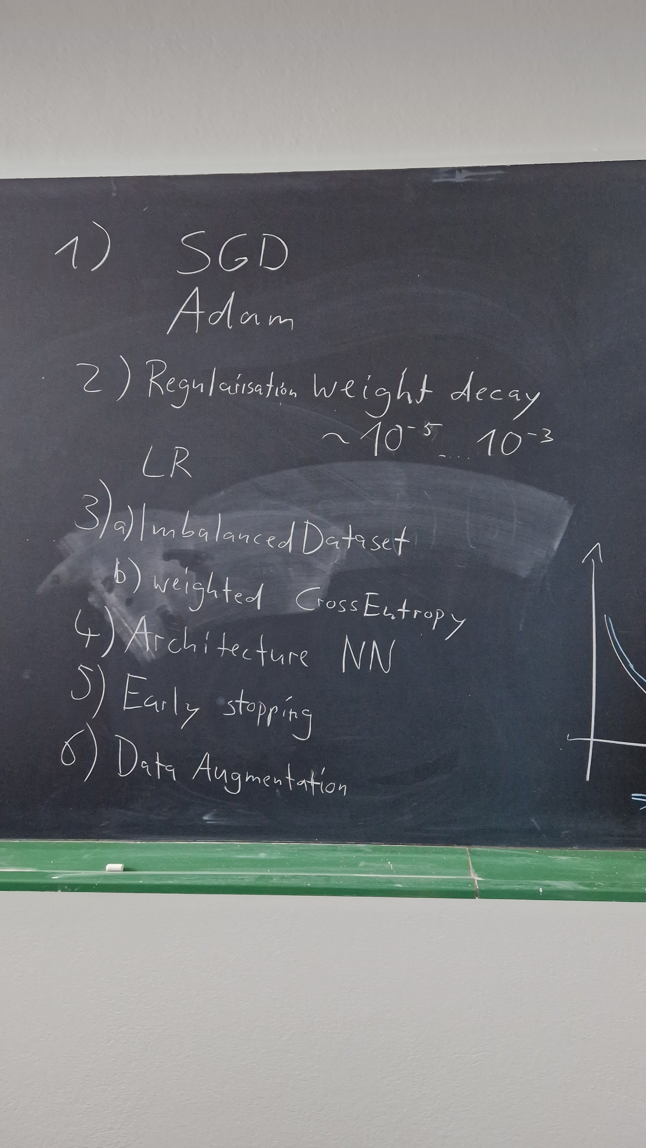

Improving the model to +95

Optimalization the hyper-parameters

* Library
* Inhaling
* Etc

Use pre-train model ex. **Resnet-18**

Use previous wights to continue learning without analyzations the image from scratch.

**Sliding windows detection**

**Single-Shot Multiple box Detector** **(SSD)**

Region Proposals

* Selective Search
* R-CNN
* YOLO
* SegNet
* J-Net